Konstantin Stekhov

CSS490B

Report to the Assignment 2

07/24/2014

How to Use the Program

1. Pick the query image to which you want to find the similar images

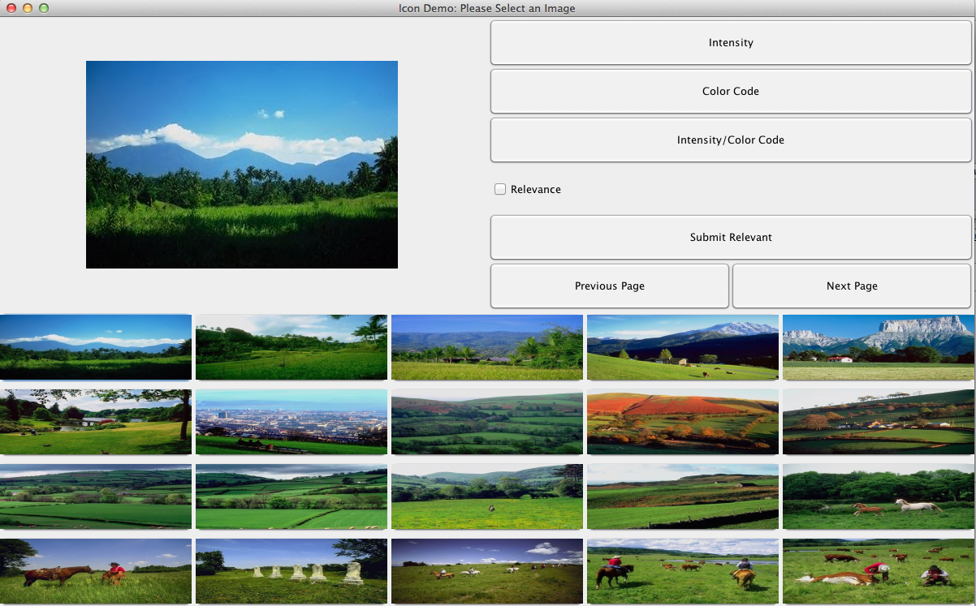

1. Click the Intensity Color code button to search by combined color code and intensity features method

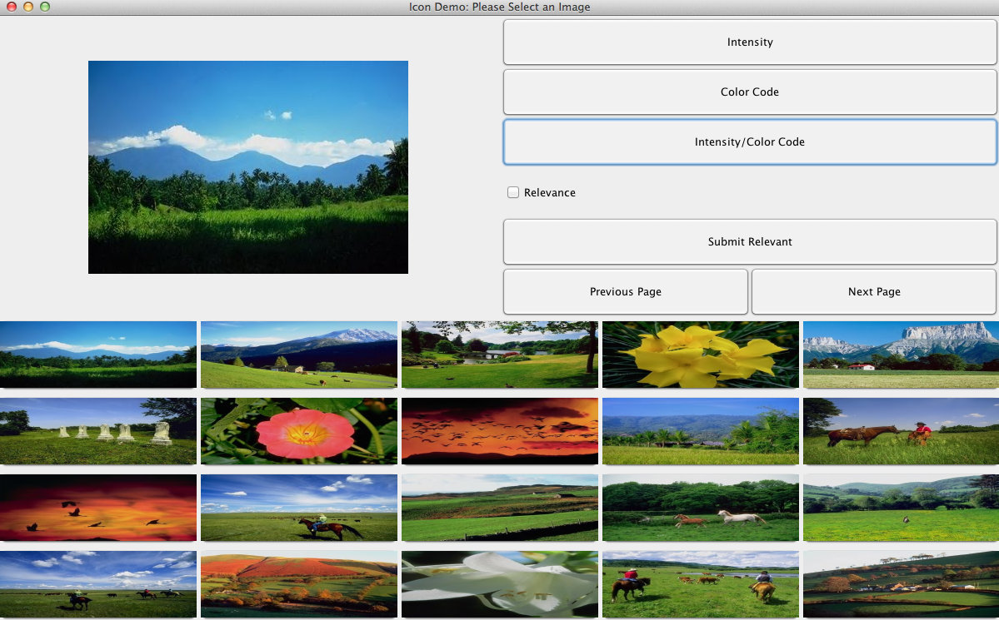

1. After getting the result click the relevant check box

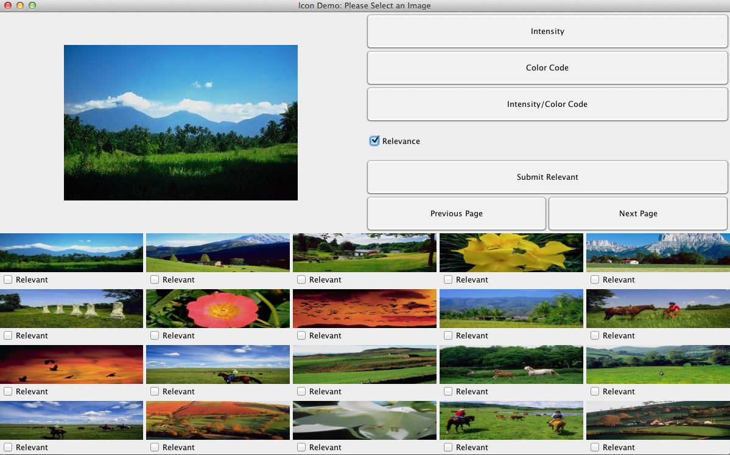

1. Select the images that are relevant

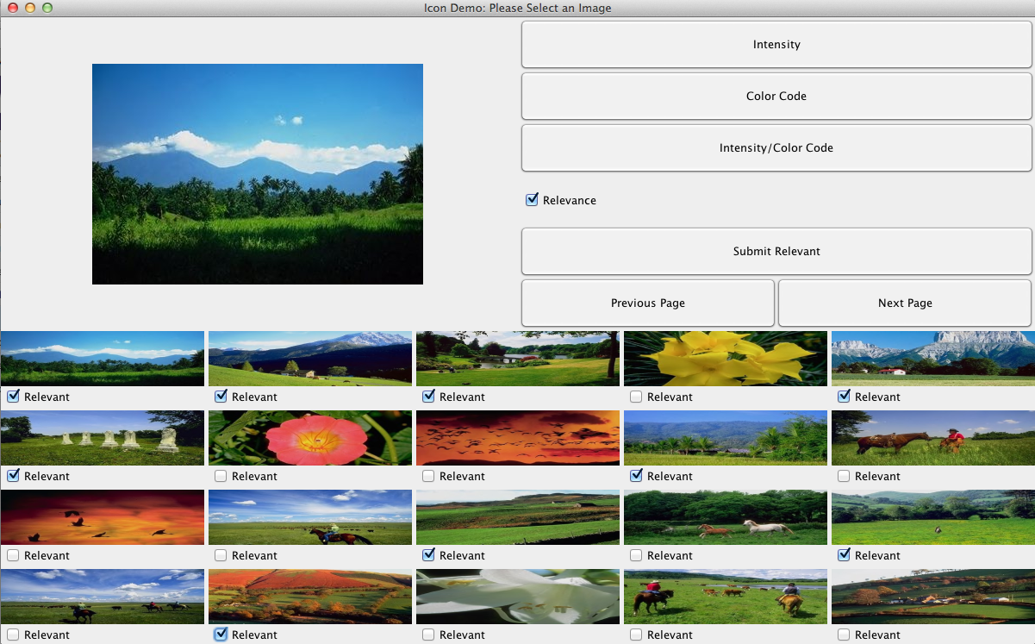

1. Click the submit relevant button

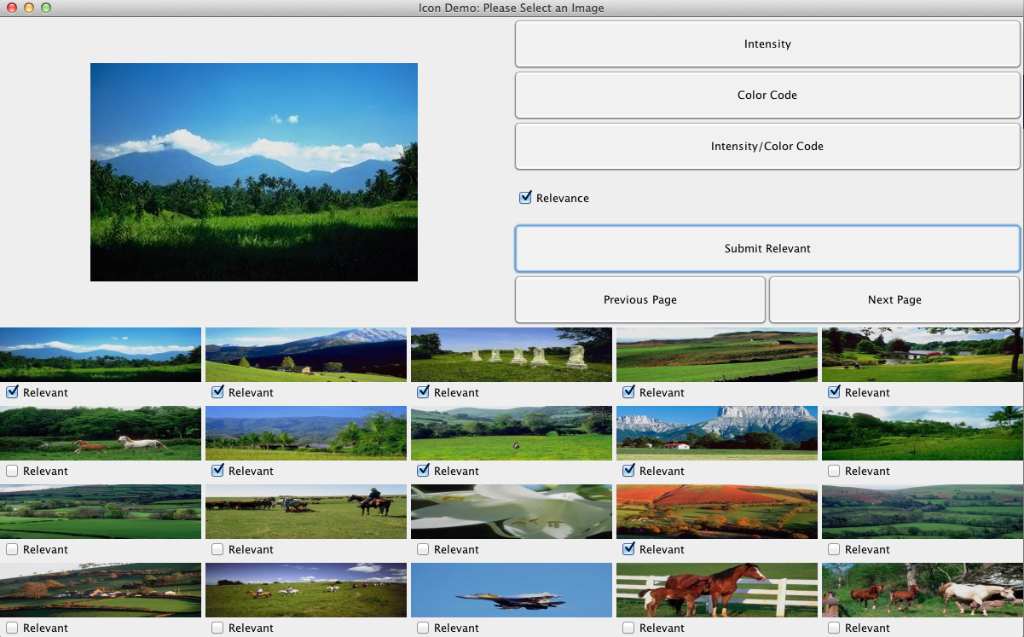

1. Select relevant images and click submit relevant button

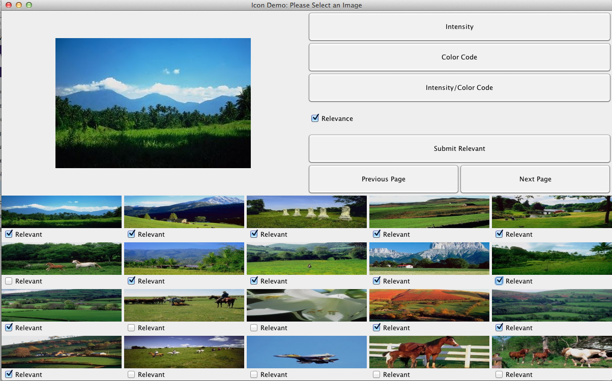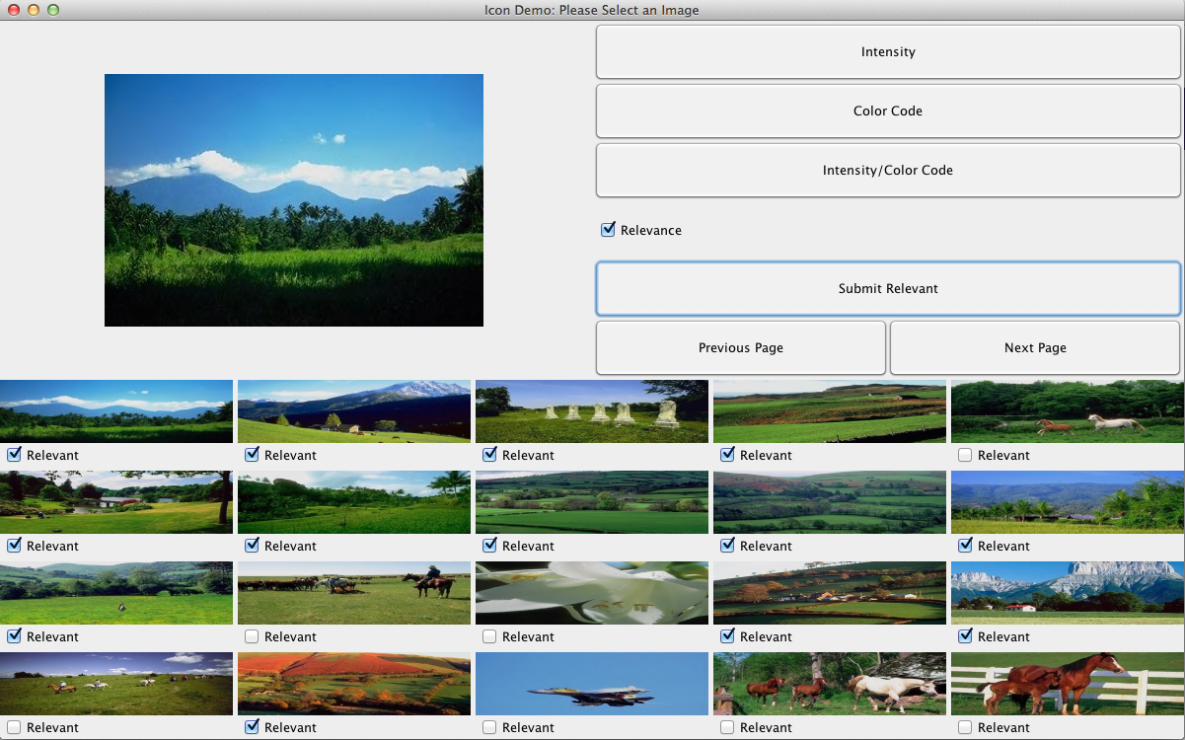

1. Select relevant images and click submit relevant button

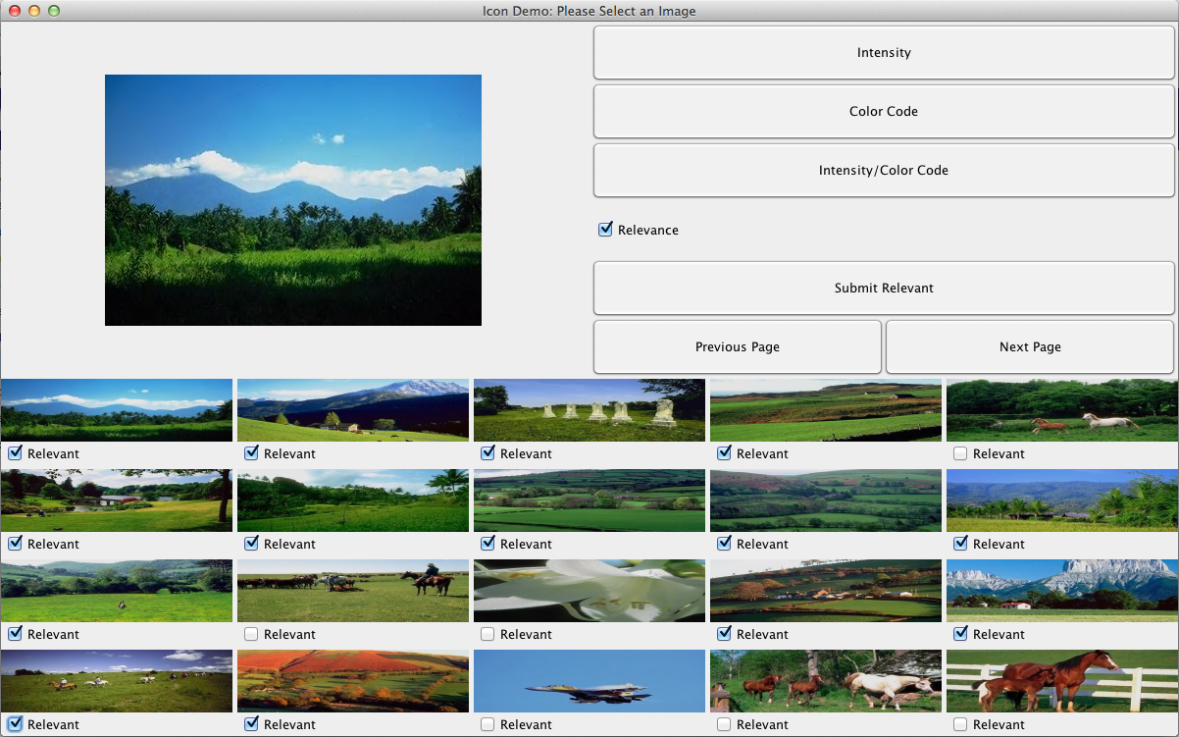

1. Result of the Intensity color code method with the relevant feedback

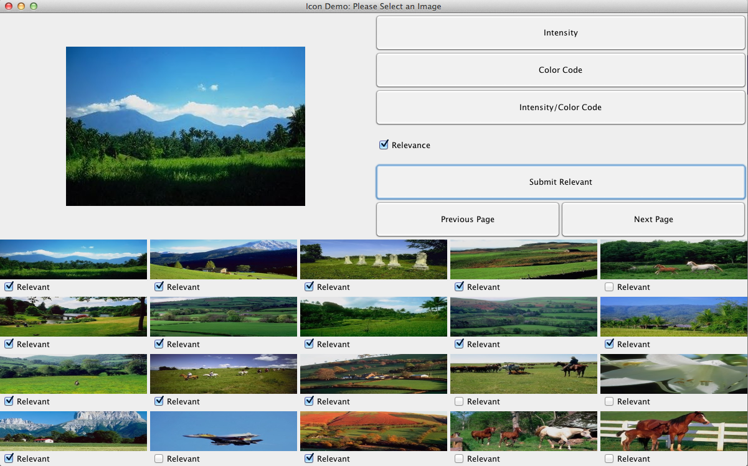

The results of the search in my application are a little bit different from those that are shown in the example on canvas but I checked all of the values and results and they are all seem correct so I don’t really know what causes it. Also, updated weights in the intermediate results posted on canvas are wrong. I even calculated them manually and they don’t make any sense. The data in the steps in excel is correct and works fine with my application.

How to Run the Program

Simply run the jar file and the program will work.

Precision Values for the First Page

Original Query: 8/20

1st iteration: 11/20

2nd iteration: 13/20

3rd iteration: 14/20